CCNA REVIEW NOTES

**DISCLAIMER: This is not an official CCNA study guide. All topics listed are in reference to the CCNA Exam Topics list posted to Cisco.com. This document assumes the reader has already studied the foundational concepts and should be used for review only.

IP Addressing

IPv4 / IPv6 Multicast Addresses:

Address For | IPv6 Address | IPv4 Address | Note
All Nodes | FF02::1 | 224.0.0.1 | NDP RA messages
All Routers | FF02::2 | 224.0.0.2 | HSRP V1,  NDP RS messages
All OSPF Routers | FF02::5 | 224.0.0.5
ALL OSPF DR/BDRs | FF02::6 | 224.0.0.6
ALL RIP Routers | FF02::9 | 224.0.0.9
ALL EIGRP Routers | FF02::A | 224.0.0.10
VRRP |  | 224.0.0.18
GLBP |  | 224.0.0.102 | HSRP V2

IPv4 Public Classes

Class A | 0.0.0.0 | 127.255.255.255
Class B | 128.0.0.0 | 191.255.255.255
Class C | 192.0.0.0 | 223.255.255.255
Loopback | 127.0.0.0 | 127.255.255.255

IPv4 Private Address Ranges

10.0.0.0 | 10.255.255.255 /8
172.16.0.0 | 172.31.255.255 /12
192.168.0.0 | 192.168.255.255 /16

IPv6 Address Types

Name | Range | Note
Global Unicast | Any that’s not reserved | Public, globally unique
Unique Local | FC00::/7 (Starts with FD) | Like an IPv4 private address
Link-Local | FE80::/10 | Auto generated with EUI-64
Multicast | FF00::/8 (Usually FF02) | One-to-many communication
Anycast | Any that's not reserved | When config., specify anycast

IPv6 Multicast Scopes

Interface-local | FF01
Link-Local | FF02
Site-local | FF05
Organization-local | FF08
Global | FF0E

EUI-64 Generation Steps

1.) | Divide MAC address in half
2.) | Insert FFFE in the middle
3.) | Invert 7th bit (2nd hexadecimal in the MAC address) Ex: 8 -> A

Solicited-node Multicast Address

ff02::1:ff [last 6 hex digits of unicast address]
Example: 2001:db8::1:f2a:4fff:fea3:91b1 → ff02::1:ffa3:91b1

NDP Message Types

RS (Router Solicitation) | ICMPv6 Type 133 | FF02::2, SLAAC messages
RA (Router Advertisement) | ICMPv6 Type 134 | FF02::1, SLAAC messages
NS (Neighbor Solicitation) | ICMPv6 Type 135 | DAD messages
NA (Neighbor Advertisement) | ICMPv6 Type 136 | DAD messages

MAC Addresses

Broadcast | ffff.ffff.ffff
HSRP V1 Virtual Format | 0000.0c07.acxx (xx = group number)
HSRP V2 Virtual Format | 0000.0c9f.fxxx (xxx = group number)
VRRP Virtual Format | 0000.5e00.01xx (xx = group number)
GLBP Virtual Format | 0007.b400.xxyy (xx = group, yy = router)
Standard STP BPDU’s Destination MAC | 0180.c200.0000
PVST+ BPDU’s Destination MAC | 0100.0ccc.cccd
LLDP Destination MAC | 0180.c200.000e
CDP Destination MAC | 0100.0ccc.cccc

Cable Topics

Copper Ethernet Cable Standards

10 Mbps | Ethernet | 802.3i | 10 Base-T | 100m
100 Mbps | Fast Ethernet | 802.3u | 100 Base-T | 100m
1 Gbps | Gigabit Ethernet | 802.3ab | 1000 Base-T | 100m
10 Gbps | 10 Gig Ethernet | 802.3an | 10G Base-T | 100m

Pin Pairs

Device | Transmits on | Received on
Firewall | 1 and 2 | 3 and 6
Router | 1 and 2 | 3 and 6
PC | 1 and 2 | 3 and 6
Switch | 3 and 6 | 1 and 2

Fiber Cable Standards

1000 Base-LX | 802.3z | 1 Gbps | Multi or Single-Mode | 550m (MM)  5 KM (SM)
10G Base-SR | 802.3ae | 10 Gbps | Multimode | 400 m
10G Base-LR | 802.3ae | 10 Gbps | Single-mode | 10 km
10G Base-ER | 802.3ae | 10 Gbps | Single-mode | 30 km

Serial Standards (WAN)

T1 (slowest) | 1.544 Mbps | North America / Japan
T2 | 6.312 Mbps | North America / Japan
T3 (fastest) | 44.736 Mbps | North America / Japan
E1 | 2.048 Mbps | Europe
E2 | 8.448 Mbps | Europe
E3 | 34.368 Mbps | Europe

Cable Terminators

Ethernet | RJ45
Fiber | ST
Point-to-Point Serial | DB-9
Coaxial | BNC
POTS | RJ-11

Duplex Errors

Symptoms | Runts, FCS and CRC errors, Alignment errors, Late collisions

If Duplex Autonegotiation is Off on One Device

Speed | Other device will try to sense speed, if it can't; it will operate at slowest supported speed
Duplex | 10 or 100 Mbps = Half duplex 1000Mbps (1Gbps) or More = Full duplex

Headers / Segments

Ethernet Header
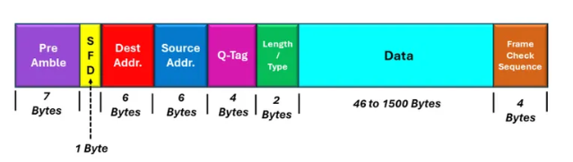

IPv4 Header

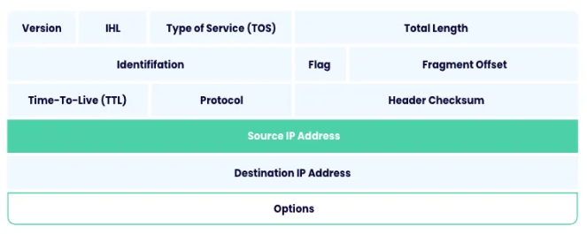

IPv6 Header

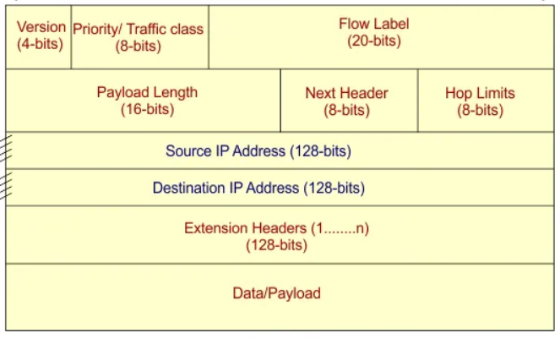

UDP Segment

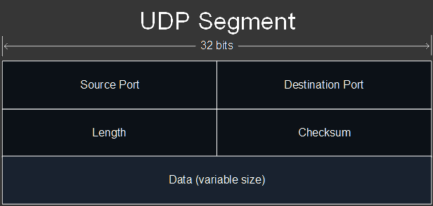

TCP Segment
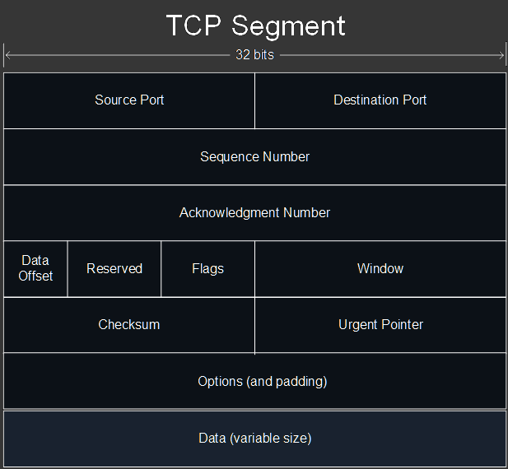

Port numbers

TCP | UDP | TCP & UDP
FTP Data (20) | DHCP Server (67) | DNS (53) (Usually UDP)
FTP Control (21) | DHCP Client (68) | DNS uses TCP > 512 bytes
SSH (22) | TFTP (69)
Telnet (23) | NTP (123)
SMTP (25) | SNMP Agent (161)
TACACS+ (49) | SNMP Manager (162)
HTTP (80) | Syslog (514)
POP3 (110) | RADIUS (1812)
HTTPS (443) | CAPWAP Control (5246)
 | CAPWAP Data (5247)

Layer 4 Port Ranges

Well-Known Ports | 0 - 1023
Registered Ports | 1024 - 49151
Ephemeral Ports | 49152 - 65535

IPv4 Header Protocol Numbers

ICMP | 1
TCP | 6
UDP | 17
EIGRP | 88
OSPF | 89

Administrative Distances

Route Protocol / Type | AD
Directly Connected | 0
Static | 1
External BGP (eBGP) | 20
EIGRP | 90
IGRP | 100
OSPF | 110
IS-IS | 115
RIP | 120
EIGRP (external) | 170
Internal BGP (iBGP) | 200
Unusable Route | 255

Random Protocol Topics

STP/RSTP Root Bridge Election

- Lowest Bridge Priority
- Tiebreaker: Lowest MAC Address

STP/RSTP Root Port Election

- Lowest Root Cost (bandwidth)
- Lowest Bridge ID (Bridge Priority + MAC Address)
- Lowest Neighbor Port ID

STP Standards

Classic STP | 802.1D
Multiple STP | 802.1s
PVST+ | Cisco upgrade to 802.1D
RSTP | 802.1w
Rapid PVST+ | Cisco upgrade to 802.1w

RSTP Port Roles

Root | To Root Bridge (forwarding)
Designated | From Root Bridge and on Some Other Bridges (forwarding)
Alternate | Backup to Root Port (discarding) superior BPDU from other switch
Backup | Usually for Hubs (discarding) superior BPDU from same switch

Etherchannel

PAgP (Cisco Proprietary) | LACP (802.3ad Standard)
Channel-protocol pagp | Channel-protocol lacp
Desirable, Auto | Active, Passive

Etherchannel Commands

Where / Type of Command | Term used | Examples
Global configuration  (config)# | port-channel | Port-channel load-balance  Interface port-channel <num>
Interface configuration  (config-if)# | channel-group | Channel-group <num> mode  Channel-protocol <protocol>
Show commands  # | etherchannel | Show etherchannel summary

Layer 3 Etherchannel Configuration

- Enable routing (L3 switches) | (config)# ip routing
- Make SVI, assign to channel-group | (config-if)# no switchport  (config-if)# channel-group 1 mode <mode>
- Enter config. For that port-channel | (config)# int port-channel 1
- Assign IP and enable | (config-if)# ip address 192.168.1.1 255.255.255.0  (config-if)# no shut

CDP / LLDP Info

Name | Timer | Holdtime | Note
CDP (Cisco) | 60 sec | 180 sec | Shows VTP in detail command, enabled by default
LLDP (802.1ab) | 30 sec | 120 sec | Tx and Rx on interfaces separately enabled, default re-initialization timer is 2 seconds

CDP Show Commands

Show cdp neighbors | Device ID, Local Int, Holdtime, Capabilities, Product Number, Neighbor Port ID
Show cdp neighbors detail | Everything in normal command + IP Address, Software Version, Native VLAN, VTP Domain
Show cdp entry <name> | Like Detail, but for a specific device in the network

OSPF DR/BDR Election

- Highest Priority (1-255), Second Highest becomes BDR (default is 1)
- Tiebreaker: Highest Router ID

OSPF Router ID Selection

- Manually Configured Router ID
- Highest Loopback Interface IP Address
- Highest Physical Interface IP Address

OSPF Neighbor States

Down | No Neighbors yet
Init | Hello received, own Router ID not in packet
2-Way | Received Hello with own Router ID, DR and BDR elected
Exstart | Choose Master/Slave, Higher Router ID becomes master
Exchange | Exchange DBDs
Loading | Send LSR and LSU to update their LSDBs
Full | Adjacency, DROthers only form Full with DR and BDR

OSPF Network Types

Broadcast | Point-to-Point | Nonbroadcast
DR and BDR elected | No DR or BDR | DR and BDR elected
Multicast | Multicast | Unicast
Ethernet and FDDI Interfaces | HDLC and PPP Interfaces | Frame Relay and X.25 Interfaces
Hello 10, Dead 40 | Hello 10, Dead 40 | Hello 30, Dead 120
Dynamic Adjacencies | Dynamic Adjacencies | Manual Adjacencies (neighbor command)

OSPF LSA Types

Type | Note
Type 1 (Router LSA) | Generated by every router, lists Router ID, networks attached
Type 2 (Network LSA) | Generated by the DR, lists routers attached to the multi-access network
Type 5 (AS-External LSA) | Generated by ASBR, advertises routes to destinations outside the AS

Requirements for OSPF Adjacency

Area Number must match
Interfaces must be in same subnet
OSPF process must not be shutdown
OSPF Router IDs must be unique
Hello and Dead timers must match
Authentication Settings must match

Other Requirements for OSPF Adjacency

IP MTU Settings must match | Become neighbors, but won’t go to Full state
OSPF Network Type must match | Prevents proper adjacency, won’t learn OSPF routes

Random OSPF Configuration Commands

Configure Cost of an Interface | (config-if)# ip ospf cost <cost>
Configure the Reference Bandwidth | (config-router)# auto-cost reference-bandwidth <mbps>
Enable OSPF Directly on an Interface | (config-if)# ip ospf <process-id> area <area num>
Enable OSPF Authentication | (config-if)# ip ospf authentication
Configure an OSPF Password | (config-if)# ip ospf authentication-key <password>
Set the OSPF Network Type on an Int. | (config-if)# ip ospf network <type>

Dynamic Routing Protocol Comparison

OSPF | RIP | EIGRP
Link-state | Distance Vector | Distance Vector
Router ospf [process-ID] | Router rip | Router eigrp [AS-number]
Network <ip> <wildcard> area <num> | Network <ip> | Network <ip> <wildcard>
Does not have auto-summary | Auto-summary enabled, default (should turn off) | Auto-summary enabled, default (should turn off)
Area must match, process-ID does not have to match between routers | n/a | AS-number must match between routers
Bandwidth (cost) metric | Hop count metric | Bandwidth (slowest link) + delay (all links) metric
Only ECMP load-balance | Only ECMP load-balance | Supports different cost load-balance (using feasible successor routes)

EIGRP Terms

Successor | Route with lowest metric to destination (best path)
Feasible Successor | Alternate route which meets the feasibility condition
Feasible Distance | The router’s own metric to the destination
Reported Distance | The neighbor’s metric value to the destination

Feasibility Condition

A route is considered a Feasible Successor if its Reported Distance is lower than the Successor route’s Feasible Distance.

FHRP Protocols

HSRP | Active, Standby (Cisco) (Load-Balance per VLAN) (ONE Virtual MAC)
VRRP | Master, Backup (Industry-standard) (Load-Balance per VLAN)
GLBP | AVG, AVF (Cisco) (Same VLAN Load-Balancing via AVFs)
HSRP Active Router Election

- Highest Priority (Default 100)
- Highest IP Address

SNMP Messages

Message Type | SNMP Message Name | Note
Read | Get, GetNext, GetBulk | Sent by NMS
Write | Set | Sent by NMS
Notification | Trap (unreliable), Inform | Sent by Managed Device
Response | Response | Response to a message

Syslog Severity Levels

0 | Emergency | Ex: Frozen or force restart the OS
1 | Alert | Ex: Failure of database auth system- halts regular operations
2 | Critical | Ex: Hardware component failure
3 | Error | Ex: Auth failures, DNS lookup failures
4 | Warning | Ex: High CPU load, certificate expiration
5 | Notice/Notification | Ex: Interface Up/Down messages, critical config. changes
6 | Informational | Ex: Successful logon or log off events, process completions
7 | Debugging | Ex: System diagnostics or troubleshooting

Remember: Every Awesome Cisco Engineer Will Need Icecream Daily

NTP Configuration

Ntp server <ip> | Sets server that device gets its time from, static client/server mode
Ntp master | Makes the device an NTP server (default stratum of 8), server mode
Ntp peer <ip> | Symmetric active mode - peers with other devices
Ntp broadcast client | Listens for broadcast messages on that port from NTP servers

DNS Configuration Commands

Configure the DNS server the router will send queries to | Ip name-server <ip>
Configure the domain of the router | Ip domain name <name>
Configure the router to act as a DNS server | Ip dns server
Enable the router to perform DNS queries | Ip domain lookup

Static NAT Configuration

Static NAT | Ip nat inside source static <inside local> <inside global>
Apply to Interfaces | Ip nat inside, ip nat outside

Dynamic NAT/PAT Configuration

Create Pool | Ip nat pool <name> <start ip> <end ip> netmask <mask>
Create ACL | Access-list <acl number> permit <source network> <wildcard>
Config. NAT/PAT | Ip nat inside source list <acl num> pool <pool name> [overload]
Apply to Interfaces | Ip nat inside, ip nat outside

DHCP Messages

Message | Sent by | Note
DISCOVER | Client | Broadcast
OFFER | Server | Broadcast or Unicast
REQUEST | Client | Broadcast
ACK | Server | Broadcast or Unicast
RELEASE | Client | Unicast, release a DHCP IP address
NAK | Server | Server declines a client request
DECLINE | Client | Declines a server offered DHCP IP address

DHCP Snooping Message Checks

DHCP Messages Received on Untrusted Port | Snooping Checks
DISCOVER, REQUEST | Source MAC to CHADDR for match
RELEASE, DECLINE | Source IP to Interface for match (binding)

DHCP Snooping Configuration List

Enable DHCP Snooping Globally, and on VLANs | (config)# ip dhcp snooping  (config)# ip dhcp snooping vlan <vlan-ids>
*For L2 Switches (Access switches): disable Option 82 | (config)# no ip dhcp snooping information option
Trust interfaces connected to servers / upstream networking devices | (config-if)# ip dhcp snooping trust
Enable Rate Limiting (Best practice) | (config-if)# ip dhcp snooping limit rate <pps>

DAI Message Checks

Sender MAC to Sender IP in DHCP Snooping Binding Table and/or ARP ACL

DHCP Snooping vs DAI Comparison

DHCP Snooping | DAI
Needs 2 Commands to enable (1 global, 1 on a VLAN)  (ip dhcp snooping) (ip dhcp snooping vlan [vlan-id]) | Only needs one command to enable  (ip arp inspection vlan [vlan-id])
Rate limiting disabled by default | Rate limiting enabled by default (15 pps)

Port-Security Defaults

After the switchport port-security command on an interface:
Max of 1 MAC address allowed (Dynamically learned)
Violation mode: Shutdown
Static MAC Address Aging Disabled
No Errdisable Recovery
*Remember: Port-Security only allowed on Static Access or Trunk ports, DTP must be off

Port-Security Violation Modes

Shutdown | Restrict | Protect
Errdisable Interface if violated | Interface stays up, drops unknown packets | Interface stays up, drops unknown packets
Generates SNMP/Syslog messages | Generates SNMP/Syslog messages | Does not generate SNMP/Syslog messages
Increments violation counter | Increments violation counter | Does not increment violation counter

SSH Config List

- Hostname (hostname <name>)
- Domain Name (ip domain-name <name>)
- Generate Key Pair (crypto key generate rsa)
- Username and Password (username <name> secret <password>)
- VTY config (line vty 0 15) (transport input ssh) (login local)

ACL Types

ACL Type | Numbered Range | Should Be Configured Closest To
Standard | 1-99, 1300-1999 | Closest to Destination
Extended | 100-199, 2000-2699 | Closest to Source

Apply an ACL

Apply ACL to VTY Lines | access-class <name/number> [in/out] ← IPv4  ipv6 access-class <name/number> [in/out] ← IPv6
Apply ACL to Interface | ip access-group <name/number> [in/out] ← IPv4  ipv6 traffic-filter <name/number> [in/out] ← IPv6
Apply ARP ACL to DAI | ip arp inspection filter <acl name> vlan <vlan num>

Security

Password Configuration Commands

Enable secret <password> | Configures and encrypts a clear-text password for privileged exec mode (md5)
Enable password <password> | Configures a clear-text password for privileged exec mode
Service password-encryption | Enables global password encryption
Password 7 <hash> | Configures an encrypted vty login password (type 7)
Enable secret 5 <hash> | Configures a previously encrypted password for enable mode (md5) (Must plug in a hash, not the actual password)
Enable secret level <num> <password> | Configures a password to access a specified privilege level (0-15)
Username <name> [privilege (0-15)] {password (encryption-type) <password>} | Configure a user account with a certain privilege level.  *Can replace password with secret for md5 encryption

Password Encryption Levels

Type 0 (clear-text) | Enable password
Type 5 (md5) | Enable secret
Type 7 (weak) | Service password-encryption
Type 9 (scrypt) | User <name> algorithm-type scrypt secret <password>

Privilege Levels

15 | Privileged Exec mode, most commands issued here
1 | User Exec mode, default nonprivileged login prompt level
0 | 5 commands default - disable, enable, exit, help, logout

AAA Authentication Configuration

Create Model | (config)# aaa new-model
(As Needed) Define RADIUS Server | (config)# radius-server host <ip> key <password>
Create AAA list | (config)# aaa authentication login {default | list-name} <method(s)>
Apply to Console/Vty lines | (config-line)# login authentication {default | list-name}

TACACS+ and RADIUS

TACACS+ (Cisco) | RADIUS (Industry)
TCP 49 | UDP 1645, 1812
Encrypts entire packet | Doesn't encrypt entire packet
Can authorize a user to a subset of CLI Commands | Does not support subset authorization function

Random Timers (Defaults)

OSPF LSA max age | 30 minutes
Err-disable recovery interval | 5 minutes
STP Timers | Hello = 2 seconds, Max Age = 20 seconds Forward Delay = 15 seconds
RSTP Timers | Hello = 2 seconds, Keepalive = 3 BPDUs
Dynamically learned MAC Addresses | Aging time = 5 minutes
HSRP Timers | Hello = 3 seconds, Holdtime = 10 seconds

QoS Topics

Methods to Classify Traffic

PCP (also known as CoS) | 802.1Q VLAN tag (Ethernet Header) Only on Trunk links, or Access ports with Voice VLAN (PC traffic not tagged)
DSCP | Layer 3 QoS (IP Header)

DSCP Markings

DF (Default Forwarding) | Best Effort (value of 0)
EF (Expedited Forwarding) | Usually Voice (value of 46)
AF (Assured Forwarding) | AFxy (x=priority, y=drop precedence)
CS (Class Selector) | 8 values (backwards compatibility with IPP)

Assured Forwarding Values

AF41 (Best Treatment) | AF42 | AF43
AF31 | AF32 | AF33
AF21 | AF22 | AF23
AF11 | AF12 | AF13 (Worst Treatment)

RFC Recommendations

Voice Traffic | EF (Expedited Forwarding)
Interactive Video | AF4x
Streaming Video | AF3x
High Priority | AF2x
Best Effort | DF (Default Forwarding)

PoE Standards

Name | Standard | Watts | Powered Wire Pairs
Cisco Inline Power | Cisco | 7 | 2
PoE (type 1) | 802.3af | 15 | 2
PoE+ (type 2) | 802.3at | 30 | 2
UPoE (type 3) | 802.3bt | 60 | 4
UPoE+ (type 4) | 802.3bt | 100 | 4

Interactive Audio Recommendations

One-Way Delay | 150ms or less
Jitter | 30ms or less
Loss | 1% or less

VoIP Configuration Commands

Switchport voice vlan dot1p | Separates voice and data traffic, but does not create a separate voice VLAN
Switchport voice vlan none | Disable the voice VLAN, voice and data traffic unseparated
Switchport voice vlan <num> | Sends voice traffic tagged in the configured voice VLAN
Switchport voice vlan untagged | Voice traffic goes through the native/default VLAN

WAN Topologies

Metro Ethernet Topologies

Name | Topology Type | Note
E-Line | Point-to-point | Similar to Leased Line
E-LAN | Full Mesh | Acts like a LAN
E-Tree | Hub and Spoke | Remote sites must go through Central site

MPLS Types

MPLS Layer 3 VPN | MPLS Layer 2 VPN
CE routers form OSPF adjacencies with PE routers | CE routers only form OSPF adjacencies with other CE routers
WAN operations, each branch has own IP subnet | WAN is invisible, acts like a giant LAN switch

VPN Types

Site-to-site VPN | Remote-Access VPN
Usually office to office, permanent, multiple devices supported | On demand, one device creates VPN to connect to the enterprise network
IPsec encryption | TLS encryption
IPsec + GRE for tunnels | Forms tunnels through TLS
Does not require additional software | Requires software on end-user devices
Network Device to Network Device | User Device to Network Gateway Device

Wireless Topics

Wireless Standards

802.11 | 2.4Ghz | 2 Mbps
802.11b | 2.4 Ghz | 11 Mbps
802.11a | 5 Ghz | 54 Mbps
802.11g | 2.4 Ghz | 54 Mbps
802.11n | 2.4 / 5 Ghz | 600 Mbps | Wi-Fi 4
802.11ac | 5 Ghz | 6.93 Gbps | Wi-Fi 5
802.11ax | 2.4 / 5 / 6 Ghz | 4*802.11ac | Wi-Fi 6

Wireless Standards Misc.

802.11v | Network-assisted power savings, uses DMS, client can sleep
802.11r | Fast transition roaming, perform PMK calculation in advance
802.11w | Management Frame Protection, security mechanism
802.11k | Assisted roaming, Client requests a list of candidate transition APs

802.11 Frame Order
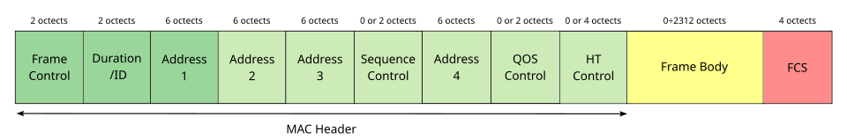

802.11 Message Types

Management | Control | Data
Beacon | RTS (Request to Send) | Used to send data packets
Probe request, response | CTS (Clear to Send)
Authentication | ACK
Association request, response

RF Terms

Amplitude | Height of a wave from trough to crest
Wavelength | Length of a wave from crest to crest
Frequency | Number of waves per given time period
Absorption | Wireless signal passes through material, weakening signal
Reflection | Signal bounces off a material, ex. metal
Refraction | Signal goes through a medium, changes direction and speed
Diffraction | Wave encounters object and travels around it, can cause blind spots
Scattering | Material causes signal to scatter in all directions, ex. dust, smog

Service Sets

IBSS | Clients connect directly, no AP needed (ad hoc)
BSS | Clients connect to a single AP
ESS | Multiple APs connect via wired network, each BSS has same SSID, different BSSIDs, different channels
MBSS | APs connect to each other wirelessly, one channel for AP connection, one channel for the BSS

AP Overlap

Acceptable overlap for consistent roaming = 10-15%

Autonomous AP Modes

Repeater | Extend range of BSS
WGB (Workgroup Bridge) | Wireless client of another AP, connect wired client to wireless network
Outdoor Bridge | Long distance, point-to-point

Lightweight AP Modes

Local | Default, sends all client traffic for all WLANs in CAPWAP to the WLC
FlexConnect | Local, but can act Autonomous if connection to WLC goes down
Sniffer | No BSS offer, sends traffic to Wireshark or similar
Monitor | No BSS, to detect and disassociate rogue devices
Rogue Detector | No radio, detects rogue devices on the wired network
SE-Connect | No BSS, dedicated to RF spectrum analysis
Bridge | Bridge for long distance, can form mesh
Flex Plus Bridge | FlexConnect + Bridge mode

WLAN Architectures

Autonomous | Autonomous AP, configured manually, all logic on the AP, connects via trunk port,
Lightweight | Split-MAC, AP handles lightweight functions, WLC does everything else, Lightweight AP connects via access port
Cloud-Based | Between Split-MAC and Autonomous, can configure itself, only management/control traffic is sent to the WLC

WLC Deployments

Unified (Hardware in central location) | Max 6000 APs
Cloud-Based (WLC is a VM on a server) | Max 3000 APs
Embedded (WLC in a switch) | Max 200 APs
Mobility Express (WLC in an AP) | Max 100 APs

WLC Ports (Physical)

Service Port | Dedicated management port, must connect to access port (one VLAN)
Distribution System Port | Standard network port, wireless to wired network, can form a LAG
Console Port | Console, RJ45 or USB
Redundancy Port | Connect to another WLC - form HA (High Availability) pair

WLC Interfaces (Logical)

Management | Management traffic (Telnet, SSH, HTTP(S), RADIUS, CAPWAP)
Redundancy Management | To connect and manage the “standby” WLC in the HA pair
AP-Manager | Manage the lightweight APs, source IP for the lightweight APs
Virtual | Communicate with wireless clients - relay DHCP requests, etc.
Service Port | Bound to physical service port, out-of-band management
Dynamic | Map WLAN to VLAN, send wireless to the wired LAN

CAPWAP Tunnels

Control (UDP 5246) | Data (UDP 5247)
Configure APs, control/management operations | Traffic from wireless clients sent through this tunnel
Encrypted by default | Not encrypted by default

Encryption and Integrity Protocols

Protocol | Encryption | Integrity | Used In
TKIP | RC4 | MIC | WPA
CCMP | AES Counter Mode | CBC-MAC | WPA2
GCMP | AES Counter Mode | GMAC | WPA3

WPA2/3 Modes

WPA2 Personal | PSK Authentication
WPA2 Enterprise | 802.1x + EAP Authentication
WPA3 Personal | SAE to replace PSK handshake (protection against dictionary attacks) + PMF (Protected Management Frames)
WPA3 Enterprise | 802.1x + EAP Authentication, Mandatory PMF

Wireless Authentication

Open Authentication | Client sends authentication request, no questions asked
WEP | Auth and encryption (RC4), shared key protocol, AP sends challenge phrase
LEAP | Client provides User and Pass, mutual auth via challenge phrases
EAP-FAST | PAC from server to client, TLS tunnel created, then client auth happens in TLS tunnel
PEAP | Digital certificate to auth the server and establish TLS tunnel, then client auth inside of TLS tunnel
EAP-TLS | Requires a certificate on the AS and every supplicant, TLS tunnel used to exchange encryption key information

WLAN GUI Security

VPN Pass-through | Layer 3 | Security for WLANs
Web Authentication | Layer 3 | Security for Guest LANs
Web Passthrough | Layer 3 | Access for Guest LANs
802.1x | Layer 2 | EAP + Dynamic WEP Key
None + EAP Passthrough | Layer 2 | Open auth + remote EAP auth
WPA + WPA2 | Layer 2 | WPA or WPA2
802.1x + CCKM | Layer 2 | 802.1x clients won’t need to reauthenticate when roaming

WLC GUI Tabs

Monitor | WLANs | Controller | Wireless | Security | Management
See AP and Client Summary | Create/edit WLANs, (general, security, QoS, Advanced) | Create/edit interfaces, manage ports | View APs, edit AP modes,  radio config., QoS config. | Create/apply CPU ACLs,  View AAA settings | View Management Settings, config. management connections

WLAN GUI QoS Settings

Platinum (voice)
Gold (video)
Silver (best effort) (default)
Bronze (background)

WLC CLI Configuration Commands

Allow HTTP connections (disabled by default) | config network webmode {enable | disable}
Allow HTTPS connections (enabled by default) | config network secureweb {enable | disable}
Enable/disable Telnet connections | config network telnet{enable | disable}
Enable/disable SSH connections | config network ssh {enable | disable}
Config. minutes of inactivity before timeout from telnet/SSH sessions (0 = no timeout) | config sessions timeout <timeout>
Config. number of simultaneous Telnet/SSH sessions allowed | config sessions maxsessions <session_num>

Virtualization

VMs and Containers

Virtual Machines | Containers
Require a Hypervisor | Do not require a Hypervisor (shares a kernel)
Has dedicated resources | Share host resources
Requires more overhead | Requires less overhead

Automation and SDN

SD-Access Deployments

Greenfield (Optimal) | Brownfield
Entirely new deployment | Uses existing network
DNA Center configures the underlay | Underlay not configured by DNA Center
All switches and links are Layer 3 | Some switches might be Layer 2
IS-IS used as routing protocol | Any routing protocol (recommended IS-IS)
No need for STP | Layer 2 switches still need STP
No need for a FHRP | Layer 3 switches use a FHRP
Access layer switches are default gateway | Distribution switches are default gateway

SD-Access Protocols

Cisco TrustSec | Provides policy control
LISP | Provides the control plane
VXLAN | Provides the data plane

SD-Access Layers

Application Layer | Contains scripts, applications; talks to the Northbound API
Control Layer | Contains the Controller (DNA Center, now called Catalyst Center)
Infrastructure Layer | Contains the network devices that forward messages on the network

SD-Access Architecture

Underlay | The physical network of devices and connections, switches use a separate IP address space than the rest of the enterprise
Overlay | The virtual network built on top of the underlay, uses VXLAN
Fabric | Combination of overlay and underlay, the network as a whole

SD-Access Underlay Switch Roles

Edge Node | Connects to end hosts
Border Node | Connects to devices outside SD-Access domain, ex: WAN routers
Control Node | Uses LISP for control plane functions

CRUD to HTTP Messages

CRUD Acronym | HTTP Message Equivalent | Example
Create | POST | Generate + retrieve token
Read | GET | Retrieve data from object
Update | PUT, PATCH | Add/modify object
Delete | DELETE | Remove an object

HTTP Response Codes

Class of Response | Class Name | Example
1xx | Informational | 102 - Processing
2xx | Successful | 200 - OK,  201 - Created,  202 - Accepted
3xx | Redirection | 301 - Moved Permanently  302 - Moved Temporarily
4xx | Client Error | 401 - Unauthorized (auth fail)  404 - Not Found
5xx | Server Error | 500 - Internal Server Error

Data Serialization Languages

JSON | XML | YAML
REST API Usage | REST API Usage | REST API Usage (not often)
Whitespace Insignificant | Whitespace Insignificant | Whitespace Significant
Key:value | <key>value</key> | Key:value
“Interface f/01”:{“status”:”up”} | <int>G0/1</int> | - interface: G0/1

REST Authentication

Basic Authentication | Username + Password in HTTP Authorization Header
Bearer Authentication | Token in HTTP Authorization Header - Tokens expire
API Key Authentication | Static Key issued by API - valid until revoked
OAuth 2.0 | Grants third parties limited access to resources - access delegation  Ex: logging in with Google

Ansible and Terraform

Ansible | Terraform
Agentless | Agentless
Push Model | Push Model
Configuration Management Tool | Infrastructure Provisioning Tool
Procedural | Declarative
Python (Playbooks written in YAML) | Core written in GO, Files written in HCL
Red Hat (Open source) | HashiCorp

Miscellaneous

Hardware

CPU | Management and Control plane operations
ASIC | Data plane operation, processes data traffic for forwarding
TCAM | Stores tables, ACLs, QoS lookups, returns entry to ASIC for forwarding

Formulas

Conversion | Formula | Example
AF to DSCP | 8x + 2y (x = Priority, y = Drop Precedence) | AF32 = 8(3) + 2(2) = DSCP 28
CS to DSCP | 8(CS value) | CS2 = 8(2) = DSCP 16
Prefix to Usable Hosts (IPv4) | $2^{h}-2$ (h = host bits) | /24 = 8 host bits,  $2^{8}-2 = 254$ usable hosts
Prefix to Usable Hosts (IPv6) | $2^{h }$(h = host bits) | /120 = 8 host bits  $2^{8}= 256$ usable hosts  *IPv6 does not reserve first or last addresses (network and broadcast)
OSPF Interface Cost | Reference Bandwidth / Interface Bandwidth = Cost | Default Reference = 100Mbps  100/1000(GigEthernet) = 1  *Lowest cost can only be 1
EIGRP Metric | Bandwidth (slowest link) + Delay (all links) = Metric  What really happens:  [(10,000,000 / bandwidth in kbps) + (total delay in usec / 10)] x 256 | 100 Mbps = 100,000 Kbps  Total Delay = 400 usec  $10,000,000/100,000 = 100$  $400/10 = 40$  So:  $256 × (100+40)=35,840$ Metric

References

CCNA Exam Topics https://learningnetwork.cisco.com/s/ccna-exam-topics

Jeremy’s IT Lab Playlist https://youtu.be/H8W9oMNSuwo

Cisco Wireless Controller Configuration https://www.cisco.com/c/en/us/td/docs/wireless/controller/8-5/config-guide/b_cg85/administration_of_cisco_wlc.html#ID562

Boson ExSim https://boson.com/exsim-max-practice-exams/

